**ASSIGNMENT NO.-G-26**

**Title:**

Any application defining scope of Formal parameter, Global parameter, Local parameter accessing mechanism and also relevance to private, public and protected access. Write a Java program which demonstrates the scope rules of the programming mechanism.

**Objectives:**

To understand concept of defining scope of Formal parameter, Global parameter, Local parameter accessing mechanism.

**Facilities:** java, 64 bit Fedora, eclipse IDE

**Theory:**

# Access Modifiers in java

1. [private access modifier](http://www.javatpoint.com/access-modifiers#accessprivate)
2. [Role of private constructor](http://www.javatpoint.com/access-modifiers#accessprivatecons)
3. [default access modifier](http://www.javatpoint.com/access-modifiers#accessdefault)
4. [protected access modifier](http://www.javatpoint.com/access-modifiers#accessprotected)
5. [public access modifier](http://www.javatpoint.com/access-modifiers#accesspublic)
6. [Applying access modifier with method overriding](http://www.javatpoint.com/access-modifiers#accessoverriding)

There are two types of modifiers in java: **access modifiers** and **non-access modifiers**.

The access modifiers in java specifies accessibility (scope) of a data member, method, constructor or class.

There are 4 types of java access modifiers:

1. private
2. default
3. protected
4. public

There are many non-access modifiers such as static, abstract, synchronized, native, volatile, transient etc. Here, we will learn access modifiers.

### 1) private access modifier

|  |
| --- |
| The private access modifier is accessible only within class. |

### Simple example of private access modifier

|  |
| --- |
| In this example, we have created two classes A and Simple. A class contains private data member and private method. We are accessing these private members from outside the class, so there is compile time error. |

1. **class** A{
2. **private** **int** data=40;
3. **private** **void** msg(){System.out.println("Hello java");}
4. }
6. **public** **class** Simple{
7. **public** **static** **void** main(String args[]){
8. A obj=**new** A();
9. System.out.println(obj.data);//Compile Time Error
10. obj.msg();//Compile Time Error
11. }
12. }

### Role of Private Constructor

|  |
| --- |
| If you make any class constructor private, you cannot create the instance of that class from outside the class. For example: |

1. **class** A{
2. **private** A(){}//private constructor
3. **void** msg(){System.out.println("Hello java");}
4. }
5. **public** **class** Simple{
6. **public** **static** **void** main(String args[]){
7. A obj=**new** A();//Compile Time Error
8. }
9. }

### 2) default access modifier

|  |
| --- |
| If you don't use any modifier, it is treated as **default** by default. The default modifier is accessible only within package. |

### Example of default access modifier

|  |
| --- |
| In this example, we have created two packages pack and mypack. We are accessing the A class from outside its package, since A class is not public, so it cannot be accessed from outside the package. |

1. //save by A.java
2. **package** pack;
3. **class** A{
4. **void** msg(){System.out.println("Hello");}
5. }
6. //save by B.java
7. **package** mypack;
8. **import** pack.*;
9. **class** B{
10. **public** **static** **void** main(String args[]){
11. A obj = **new** A();//Compile Time Error
12. obj.msg();//Compile Time Error
13. }
14. }

In the above example, the scope of class A and its method msg() is default so it cannot be accessed from outside the package.

### 3) protected access modifier

The **protected access modifier** is accessible within package and outside the package but through inheritance only.

The protected access modifier can be applied on the data member, method and constructor. It can't be applied on the class.

### Example of protected access modifier

In this example, we have created the two packages pack and mypack. The A class of pack package is public, so can be accessed from outside the package. But msg method of this package is declared as protected, so it can be accessed from outside the class only through inheritance.

1. //save by A.java
2. **package** pack;
3. **public** **class** A{
4. **protected** **void** msg(){System.out.println("Hello");}
5. }
6. //save by B.java
7. **package** mypack;
8. **import** pack.*;
10. **class** B **extends** A{
11. **public** **static** **void** main(String args[]){
12. B obj = **new** B();
13. obj.msg();
14. }
15. }

Output:Hello

### 4) public access modifier

|  |
| --- |
| The **public access modifier** is accessible everywhere. It has the widest scope among all other modifiers. |

### Example of public access modifier

1. //save by A.java
3. **package** pack;
4. **public** **class** A{
5. **public** **void** msg(){System.out.println("Hello");}
6. }
7. //save by B.java
9. **package** mypack;
10. **import** pack.*;
12. **class** B{
13. **public** **static** **void** main(String args[]){
14. A obj = **new** A();
15. obj.msg();
16. }
17. }

Output:Hello

### Understanding all java access modifiers

Let's understand the access modifiers by a simple table.

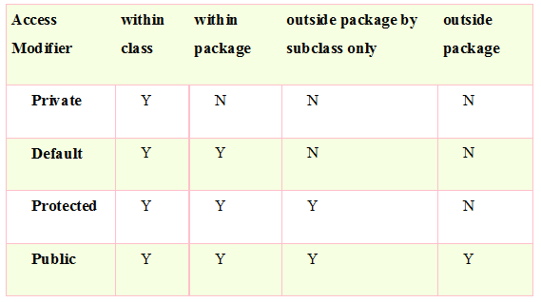

**Conclusion:** This program gives us the knowledge about various access modifiers & also scope rules of programming mechanism.

**Questions asked in university exam.**

1. Explain various java access modifiers.
2. Differentiate between various accesses modifiers.
3. WAP to explain protected access modifier.